**Carer Scheduling App User Guide**

0. Installation Guide

**Package Prerequisites**

In addition to an up-to-date installation of Python, the following packages are required to successfully execute the code:

* convertbng (0.7.4)
* hdbscan (0.8.38)
* kivy (2.3.0)
* kivy_garden (0.1.4)
* kivymd (1.1.1)
* mapview (1.0.6)
* matplotlib (3.9.2)
* numpy (1.26.4)
* openrouteservice (2.3.3)
* pandas (2.2.2)
* Pillow (10.4.0)
* requests (2.32.3)

After installing kivy_garden and matplotlib, run the following command in the terminal to also install matplotlib with kivy-garden: *garden install matplotlib*

Later versions of these packages may work as well, but these versions are guaranteed to work with the code.

**Required Files**

The following files need to be in the same directory as main.py:

* cccmd.kv
* functions.py
* me_32.png
* tr.csv

1. Home Screen

The home screen loads first when executing the main.py file. It is divided into three different sections.

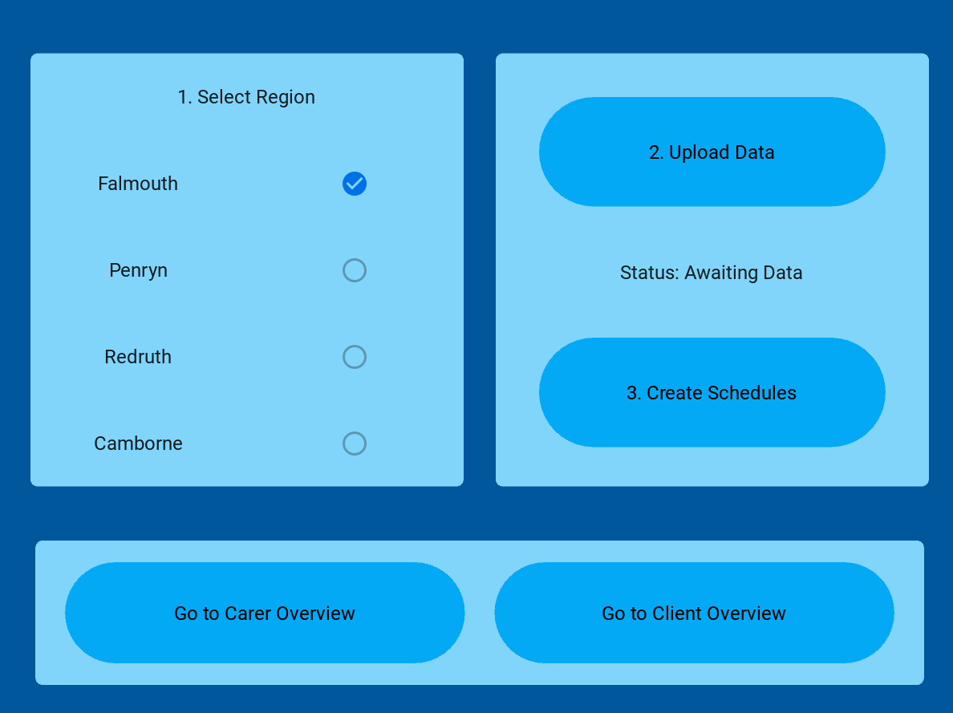

Main Screen

The top left section would allows the user to select which region is relevant for the scheduling of care visits. The default selection is Falmouth, which is also the only currently supported region. Selection of the other regions does nothing in this version of the app.

The top right section consists of two buttons. The top button allows the user to upload the client and carer data (see “Upload Data” below). After data has been uploaded, the bottom button creates the care schedule. A label indicates whether a data file has been uploaded and if the scheduling has been completed.

The bottom section consists of two buttons, which both allow the user to navigate to either the carer or client view of the completed schedule.

2. Upload Data

Pressing the “Upload Data” button opens a new window that allows the selection of a file. Selection of any file that is not in an .xls format results in an error, as does prematurely leaving the file selection screen. Clicking on a file automatically closes the file selection screen, returning the user to the main screen.

The client and carer data needs to be stored in two separate sheets of an .xls file. Any other format will result in an error.

The first sheets needs to contain client information, although the name of the sheet itself does not matter. The following columns have to be present and labelled in this exact way: “ID” (to identify each client), “Postcode” (approximating the client’s home address), and five columns that indicate during which time of day the client needs to be visited (“Early Morning”, “Morning”, “Lunch”, “Tea”, “Evening”). These columns may only contain “Yes” or “No” in this version of the app.

Each of the five latter columns corresponds to a time window (7-9 am, 9am-12pm, 12-3pm, 3-6pm, and 6-8pm, respectively). A “Yes” for one of these windows corresponds to a one hour visit taking place at any point during that time window.

Client Information Sheet

The second sheet contains information about the carers, although the name of the sheet itself does not matter. The following columns have to be present and labelled in this exact way: “ID” (to identify each carer), “Postcode” (approximating the carer’s home address), “Available Start” (a whole number, representing when the carer’s shift may start at the earliest), “Available End” (a whole number, representing when the carer's shift has to end at the latest), and “Hours” (how many hours of work the carer has to be scheduled for in a given day). For any given row, the value in the “Hours” column must be smaller than or equal to the difference between “Available End” and “Available Start”. Time is denoted in the 24-hour format.

Carer Information Sheet

Once the correct file has been selected, the main screen now indicates that the program is ready to create the care schedule (“Awaiting Data” changes to “Ready to schedule”). Pressing the “Upload Data” button again allows the user to upload a different .xls file.

|  |  |  |
| --- | --- | --- |
|  | Arrow Right with solid fill |  |

The “Create Schedules” button may only be pressed once the correct data has been uploaded. Pressing it early will result in an error.

Creating the care schedule may take a few seconds. Ensure a stable and fast internet connection, due to the scheduling involving the calculation of real-world travel times. Otherwise, the program may crash at this point. Once the program is finished, the text changes to “Scheduling complete”, as shown below.

|  |  |  |
| --- | --- | --- |
|  | Arrow Right with solid fill |  |

Only when the care schedule has been created can be carer overview and the client overview screen be used. Navigation to either screen is supported at any point in app’s usage, but interacting with any element on either screen (other than the “Return to Overview” button) before the care schedule has been created results in an error.

3. Carer Overview Screen

Pressing the “Go to Carer Overview” button brings the user to a new screen.

Carer Overview Screen

The top left box shows the schedule of a carer in the selected display type. The default display type (when no selection is made) is in text form, which returns the schedule in a scrollable text box. Alternatively, the schedule of a carer can be displayed in a table or on a map.

|  |  |  |
| --- | --- | --- |
|  |  |  |

The top right box is used to modify this display. The carer can be selected through the drop-down menu at the top right (labelled “Select Carer”).

Changing the display type from text into either table or map and then back to text might result in the text being displayed off-screen, requiring the user to scroll up to read the full text.

The map display of the schedule is interactive, allowing the user to zoom in and out. The carer’s home is denoted with a black marker, and subsequent client homes with a red marker. The route taken from each location is visualised with black points.

The button “Return to Overview” returns the user to the home screen. When returning, the text of the top left box may fail to display correctly; adjusting the window size fixes this, however.

Finally, the bottom box can be used to adjust the availability of the selected carer, allowing the start time, end time, or number of working hours to be adjusted.

Bottom box that allows for the selected carer’s schedule to be adjusted.

Entering a new start time updates the earliest time a carer may be scheduled to work. Entering a new end time updates the latest time until a carer may be scheduled to work. Finally, entering a different number of work hours changes the number of hours the carer may be scheduled to work in the day. Entering a zero indicates that the carer is unavailable to work. All three input boxes accept only whole numbers. Leaving an input box blank leaves that aspect of the carer’s information unchanged.

The bottom right bottom “Adjust schedule for _” updates based on the selected carer. Pressing the button submits the changes and reruns the program with the changes for that carer, creating a new care schedule for the day. This may take a few seconds. As before, ensure a stable internet connection when pressing this button.

The text on the button changes once all changes have been saved and the program has been rerun successfully.

|  |  |  |
| --- | --- | --- |
|  | Arrow Right with solid fill |  |

Any number of carers’ information can be adjusted in this way. Changes submitted through this process are saved until the program is closed.

4. Client Overview Screen

Pressing the “Go to Client Overview” button brings the user to a new screen.

Client Overview Screen

The top left box shows a client’s care schedule for the day. It updates based on the chosen client and display type.

The bottom left box allows the user to change display of a client’s schedule. The default selection is text form, which displays the care plan in a scrollable text box. The table display includes information about when and by whom a client is being visited, and when the client should not be visited. After changing display types, the text may be displayed off-screen, requiring the user to scroll up to read the full text.

|  |  |
| --- | --- |
|  |  |

The top right box includes a selection tool that allows the user to switch between clients. Doing so changes the checkboxes in the same box to reflect at what time of the day the client needs to be visited by a carer. A time window during which the client does not need to be visited is greyed out in the table view.

Client’s requested visits and corresponding visits. The client should not be visited in the early morning, resulting the 7-9 am time window being greyed out.

Checking and unchecking one of the five check boxes allows for the adjustment of visit times. When pressing the “Adjust Availability” button, the selection is saved and the program rerun to create a new care schedule. This may take a few seconds. As before, ensure a stable internet connection when pressing this button.

After updating the availability of a client and creating a new care schedule, the text on the button changes to reflect this update.

|  |  |  |
| --- | --- | --- |
|  | Arrow Right with solid fill |  |

The client’s displayed schedule does not update automatically. Instead, either the client or the display type need to be changed to force the top left box to update.

After updating the client’s availability, the care plan changes. The 9am-12pm time window is now greyed out since the client cannot be visited during the “Morning” time window.

Finally, the bottom right button “Return to Overview” allows the user to navigate back to the home screen. When returning, the text of the top left box may fail to display correctly; adjusting the window size fixes this, however.